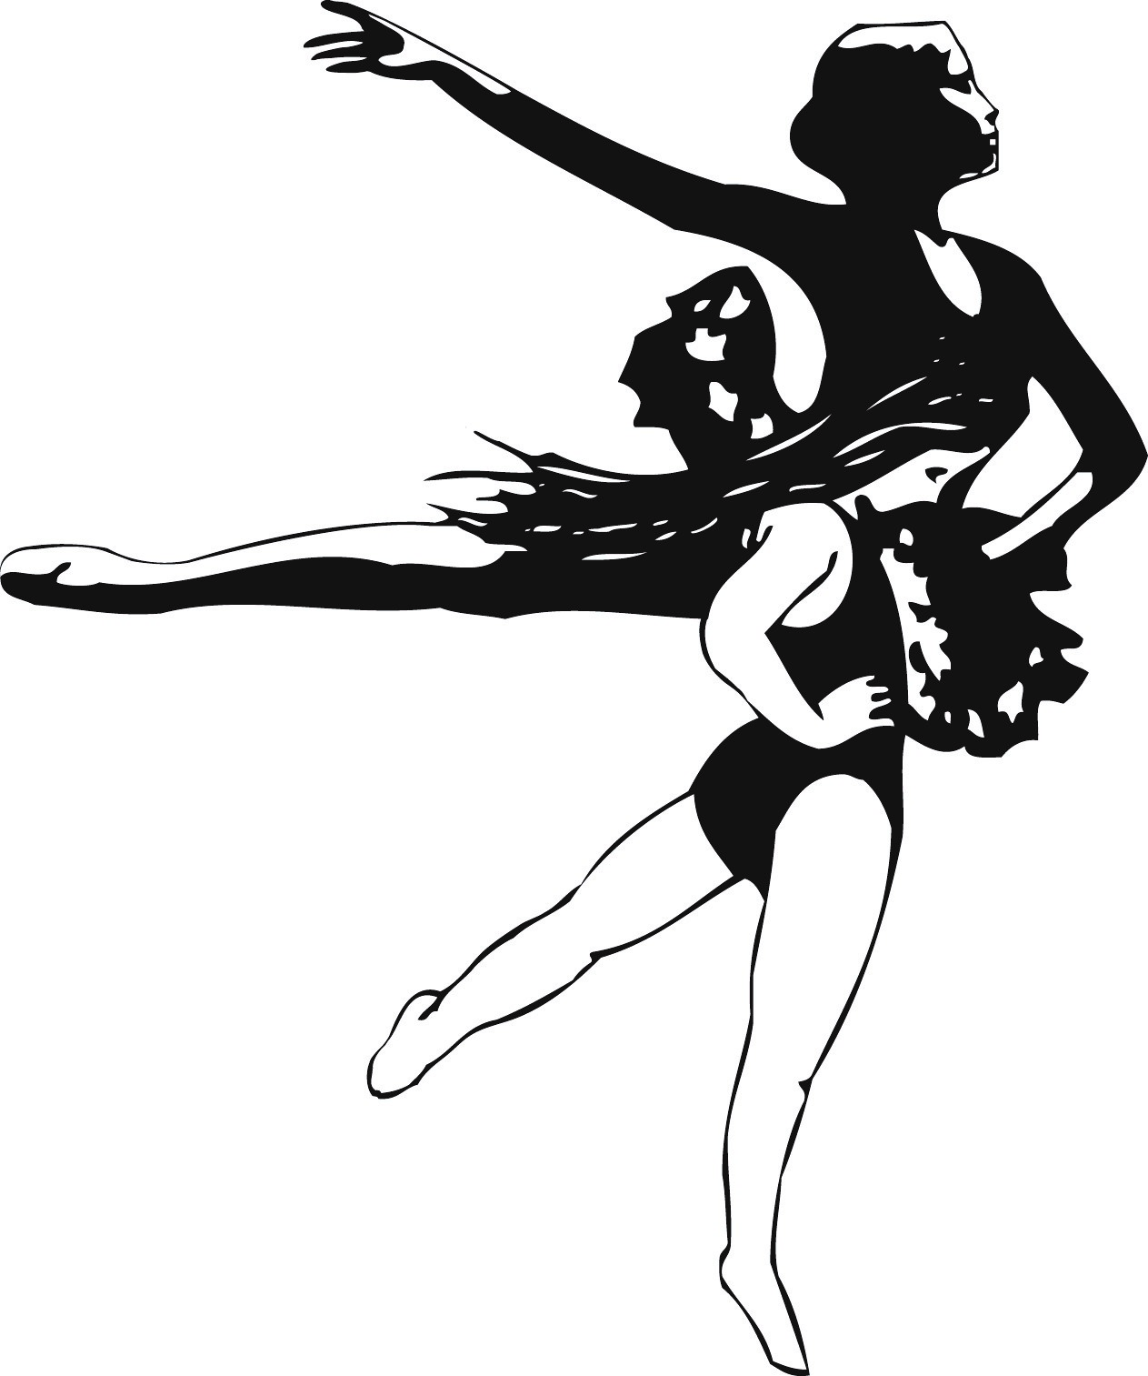

Children’s Ballet Theatre
2738 So. 2000 E., SLC, UT 84109
ChildrensBalletTheatreSLC.com
cbtdance@outlook.com
801-487-0565

CBT

Children’s Ballet Theatre
2738 So. 2000 E., SLC, UT 84109
ChildrensBalletTheatreSLC.com
cbtdance@outlook.com
801-487-0565

2021-2022 HANDBOOK
Please keep this Handbook in a place where you can easily reference it when needed.

- It is your responsibility to be aware of these payments & amounts!
- Below you will find the schedule of your tuition payments that will automatically run
- The due date for changes
- Inside, you will find the calendar for the year

2021-2022 Agreement
I understand the tuition policy is for ALL 5 TERMS
A $20 fee will automatically be charged for NSF/Declined/Late accounts
I have accepted CBT’s main form communication, “Remind!”
OR will be automatically charged $20 per term Communications Fee
TEXT Option: TO: 81010 MESSAGE: @cbtwelcome
LINK OPTION: remind.com/join/cbtwelcome
I understand that CBT has a Required Dress Code
Dress Code Leotard (Itty-Bitty, Pre-Ballet, Pre-Tech, Beginning) Payment $27
I understand All Ballet Slippers - NO Drawstring!
Hair in a Bun Always!
$10 Hair Kit will be auto charged to account if hair is not done!
For Safety & respect for others I will follow CBT’s Parking Lot Policy which is:
ONE WAY traffic with the entrance on the South side & exit from the
North side of CBT. I WILL NOT wait, drop off or pick up from the NORTH SIDE!

Adv. Fall Deposit $75 Non-Refundable & automatically run In July

2021-2022 All Payments are Automatic, Non-Transferable & Non-Refundable

Changes DUE! Tuition Posted

1st TERM Aug 24, 2021 (08/26/21)
2nd TERM Oct 26, 2021 (10/28/21)
3rd TERM Jan 4, 2022 (01/06/22)
4th TERM March 15, 2022 (03/17/22)
5th TERM May 17, 2022 (05/19/22)

CBT’s Important Dates 2021-2022

Aug 11 & 12 Mermaid Camp - 11:00-12:30pm
Aug 24 Changes to Account Due
Aug 24-25 Drosselmeyer Registration
Aug 27 1st Term Tuition Runs
Aug 27-31 CBT’s Summer Musical “Frozen Jr.”

Sept 1 Choreography Concert Auditions 3:30-7:30
Sept 7 Fall classes begin
Sept 11 Drosselmeyer Auditions
Sept 18 Choreography Concert 3:00pm & 6:30pm

Oct 16 Winter Musical Auditions
Oct 13-16 Fall Break - NO Classes Held
Oct 22-29 Mad Co. Zombie Night
Oct 26 Changes to Account Due
Oct 28 2nd Term Tuition Runs
Oct 29 Halloween Carnival 3:00-7:00pm
Oct 31 No Classes Held due to Halloween

Nov 1 2nd Term Begins
Nov 23-27 Thanksgiving Break - No Classes Held

Dec 3-11 Drosselmeyer’s Dreamland Performance
Dec 15 WinterFest Performance
Dec 20-Jan 1 Winter Break - No Classes Held

